ELECTRONIC PRESS KIT
Booking Contact- April (Pantheress) Winn (210)-823-5477
Email- onlivemagazine@yahoo.com
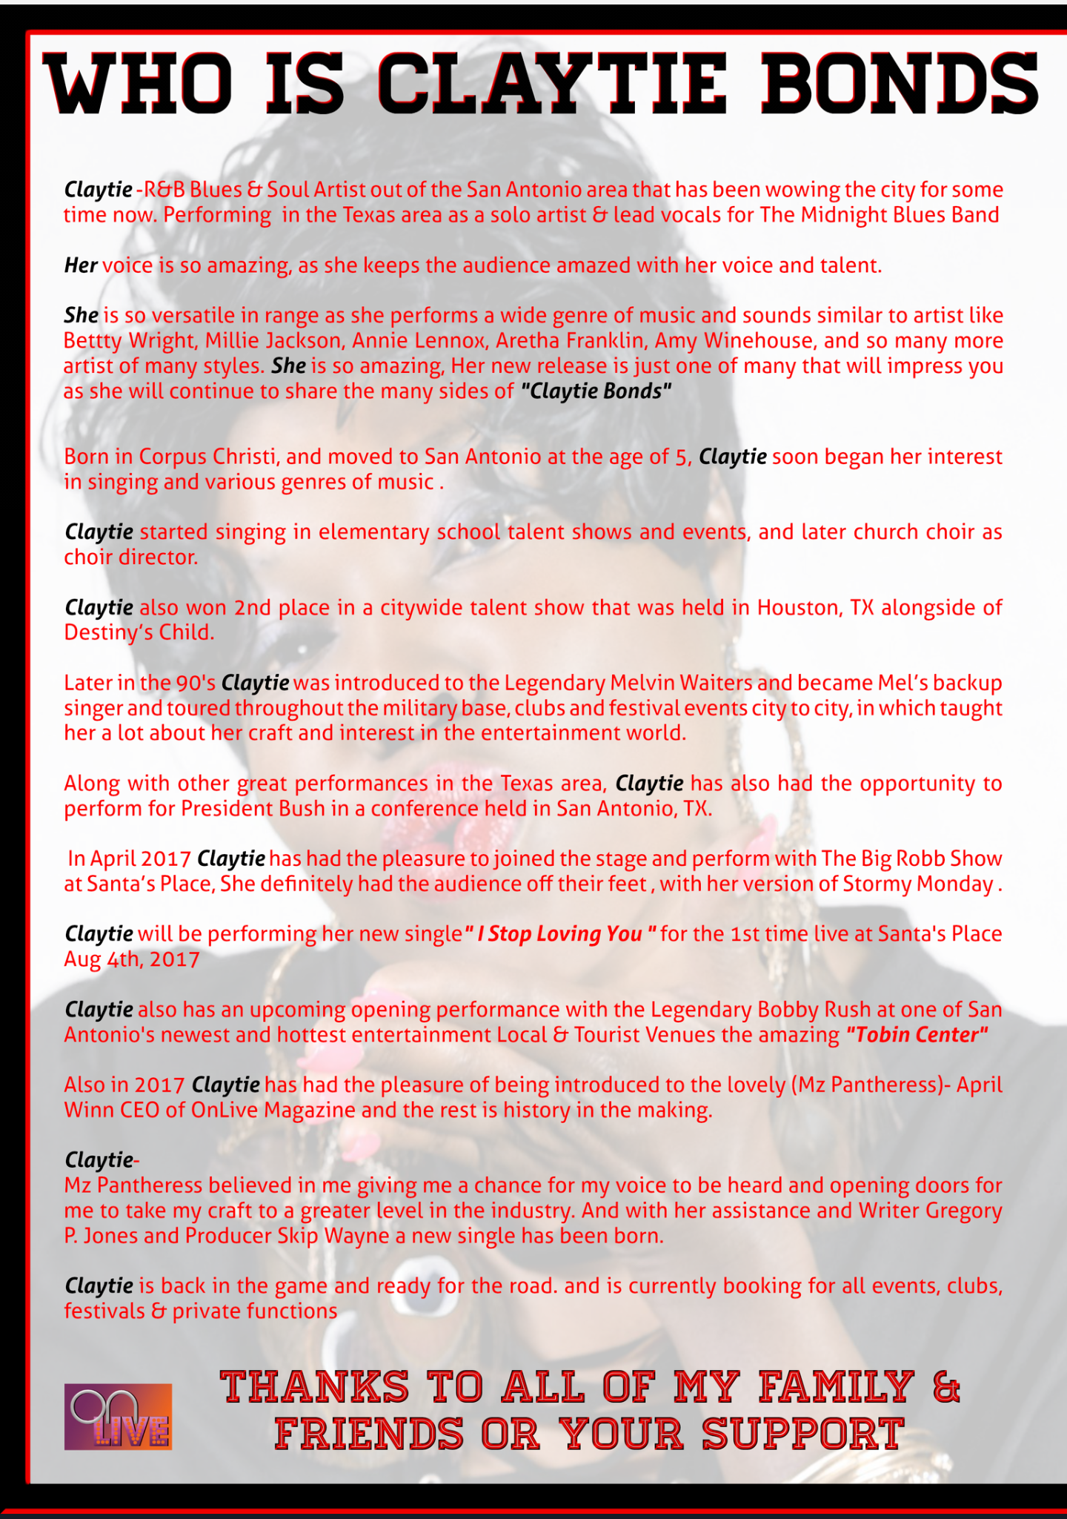
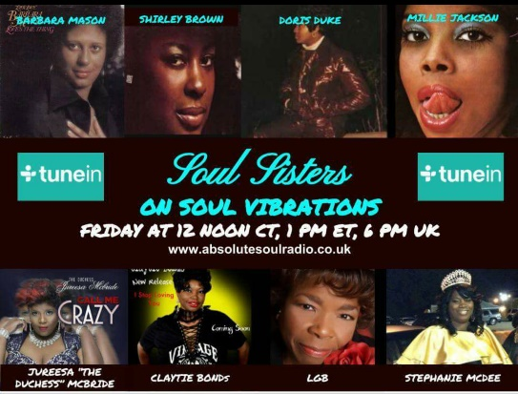
https://store.cdbaby.com/cd/claytiebonds
http://www.iluvwhatido.com/claytiebonds.html
https://www.youtube.com/watch?v=QsfZphSobI0
PHOTOS
Singing in the church choir and beautifully belting out the national anthem for civic gatherings eventually led this songbird on a path to the blues.
Claytie Bonds Lead Vocalist / After Midnight Blues Band

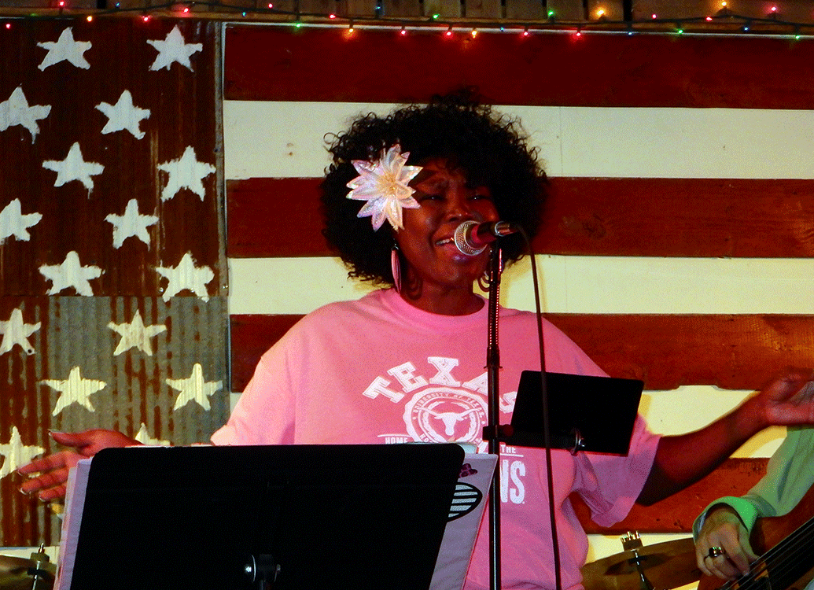
Claytie Bonds With The Marvelous Mel Waiters
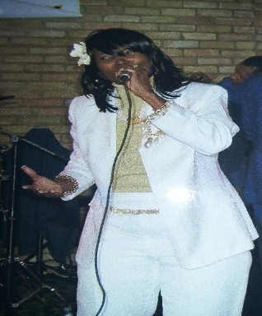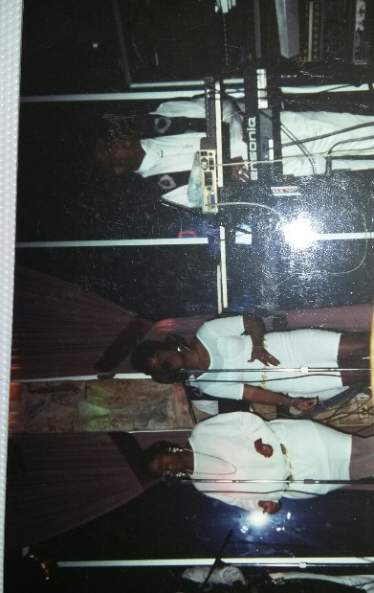
Military Tour With Mel Waiters.

